Dalton Murray

Python for Data Analysis and Visualization

Professor Shams

February 19, 2024

**Assignment #2**

**Overall**

**Task 1 – Data loading and inspection**

Load the datasets sales_q1.csv and sales_q2.csv into separate DataFrames.

Inspect the first 5 rows of each DataFrame to understand the structure of the data.

Check for any missing values in both datasets.

In task one I prepare the program by importing sys, os, pandas, numpy, and pyplot as these will be the required libraries to use in this program. I then also prepare it with my basic template putting everything into a def main and calling and exiting the def main.

For the first part of the task I easily read the supplied .csv files and make them a dataframe and set them to salesQ1 and salesQ2.

For the second part I use the .head(5) function to list out the first five rows of each of the dataframes with a little formatting.

For the third part for each of the dataframes I check what is null in the dataframe and then I print out a summary of what is null for neatness of the print statement.

**Task 2 – Basic data manipulation**

Add a new column to each DataFrame, Total_Sales, calculated as Price * Quantity.

Create a Series from the Product_ID column of the first DataFrame and explore it using methods like head(), tail(), and describe().

For the first part of task 2 I add a new column for both of the dataframes called Total_Sales I then set the column equal to the price multiplied by the quantity, after this for the second part I create a series for salesQ1 of the column Product_ID. I then print out information of the series such as its head, tail, and the description.

**Task 3 – Concatenation task**

Concatenate the two DataFrames along rows (axis=0) into a single DataFrame named combined_sales.

Ensure that the indexes are reset appropriately in the combined DataFrame.

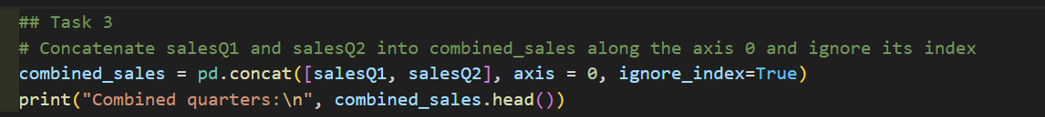

For the first part of task 3 I concatenate salesQ1 with salesQ2 along the 0 axis and I set it to ignore index to make sure that the indexes are getting set/reset properly. I then print out a head of this new concatenated list called combined_sales.

**Task 4 – Advanced data manipulation**

Group the combined DataFrame by Product_ID and calculate the total sales for each product across both quarters.

Sort the products based on the total sales in descending order.

For the first part of task 4 I make a dataframe called productGroupBy which I set to the grouped by Product ID’s and I add a summary to each of the product id’s of the total sales column. I then sort this in descending order and print it out.

**\*\*Please note that this is where I get confused of what I should be and shouldn’t be setting to the overall combined_list dataframe so if the task doesn’t explicitly say to set it to that then I don’t and treat it as if it were a branch of the dataframe rather than setting it to the dataframe. I asked about this in class and I believe this is what you said to do.**

**Task 5 – Data filtering**

Filter out the rows in the combined_sales DataFrame where Quantity sold is greater than 50.

For task 5 I filter out ever row of combined sales where the quantity is greater than 50, note that this says “Quantity” < 50 which would mean less than 50, however, that is what it is keeping not getting rid of, by doing this it is getting rid of anything that is greater than 50.

**Task 6 – Handling missing data**

If there are any missing values in Price or Quantity, fill them with the average of their respective columns.

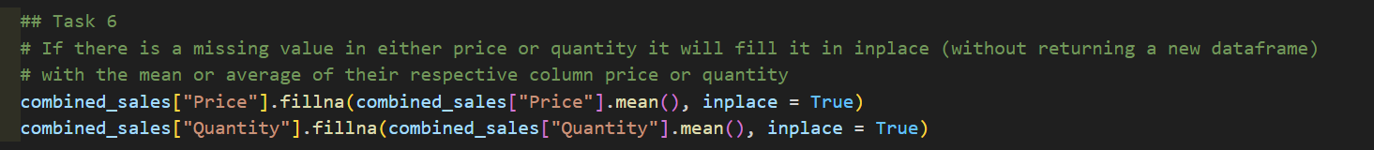

For this task, for each of the dataframes combined_sales I fill any missing or NaN valued items with the mean of their respective values I then set this to do it inplace because I want to do it directly on the combined_sales dataframe and not set it to something new.

**Task 7 – File operations**

Save the final combined_sales DataFrame to a new CSV file, combined_sales_analysis.csv.

In this task I tell the dataframe to be saved as a csv with no index.

**Task 8 – Bonus visualize**

Visualize the sales data using any library of your choice (like Matplotlib or Seaborn). You could create a bar chart showing total sales for the top 5 products.

For this task I did a very simple visualization of the example given. I took the sorted product’s top 5 rows and set it to a variable top5Products I then made a bar with its index and values as the x and y. I then put x and y labels and set a title and told it to show the bar chart.

**Code**

#####################

## Dalton Murray #

## 02/12/2024 #

## Assingment 2 #

#####################

import sys

import os

import pandas as pd # Import the pandas library and sets an alias to pa

import numpy as np

import matplotlib.pyplot as plt # Imports matplotlib pyplot library and sets an alias to plt

# Defines the __main__ function

def __main__():

## Task 1

# Sets the database location to the relative folder

database = "./"

# Sets the salesQ1 and salesQ2 variables to dataframes of the read csv's

salesQ1 = pd.read_csv(os.path.join(database, "./sales_q1-1.csv"))

salesQ2 = pd.read_csv(os.path.join(database, "./sales_q2-1.csv"))

# Prints the first 5 rows of the dataframes

print("Sales Q1:\n", salesQ1.head(5))

print("Sales Q2:\n", salesQ2.head(5))

# Checks for missing values in the dataframes by checking if a value is null

# Then summarizing/printing out the list of null values

print("Sales Q1 missing summary:\n", salesQ1.isnull().sum())

print("Sales Q2 missing summary:\n", salesQ2.isnull().sum())

## Task 2

# Adds a total sales column by multiplying the existing price by quantity for each dataframe

salesQ1["Total_Sales"] = salesQ1["Price"] * salesQ1["Quantity"]

salesQ2["Total_Sales"] = salesQ2["Price"] * salesQ2["Quantity"]

# Creates a series from the first data frame's product id column

salesQ1Series = salesQ1["Product_ID"]

# Print out information about the series

print("Sales Q1 product ID head:\n",salesQ1Series.head())

print("Sales Q1 product ID tail:\n", salesQ1Series.tail())

print("Sales Q1 product ID describe:\n", salesQ1Series.describe())

## Task 3

# Concatenate salesQ1 and salesQ2 into combined_sales along the axis 0 and ignore its index

combined_sales = pd.concat([salesQ1, salesQ2], axis = 0, ignore_index=True)

print("Combined quarters:\n", combined_sales.head())

## Task 4

# Groups the Product_ID's and then sorts it by the total sales in descending order

productGroupBy = combined_sales.groupby("Product_ID")["Total_Sales"].sum()

productSort = productGroupBy.sort_values(ascending = False)

print("Grouped & sorted products:\n", productSort)

## Task 5

# Filters out/removes the rows where quantity is greater than 50

quantityFilter = combined_sales[combined_sales["Quantity"] < 50]

print("Filtered quantity:\n", quantityFilter)

## Task 6

# If there is a missing value in either price or quantity it will fill it in inplace (without returning a new dataframe)

# with the mean or average of their respective column price or quantity

combined_sales["Price"].fillna(combined_sales["Price"].mean(), inplace = True)

combined_sales["Quantity"].fillna(combined_sales["Quantity"].mean(), inplace = True)

## Task 7

# Saves a csv file of the analysis performed

combined_sales.to_csv("combined_sales_analysis.csv", index = False)

## Task 8

top5Products = productSort.head(5)

plt.bar(top5Products.index, top5Products.values)

plt.xlabel("Product ID")

plt.ylabel("Total Sales in USD")

plt.title("Top 5 Products")

plt.show()

# Checks if the "__name__" variable equals "__main__"

if __name__ == "__main__":

sys.exit(__main__()) # Calls the "__main__" function and then after running exits smoothly

I have neither given nor received unauthorized aid in completing this work, nor have I presented someone else's work as my own.

*Dalton Murray*